**Project : SOPFIM**

**Comments Zakaria – November 14th, 2012**

**Application Message :**

1. The color of the selected bloc change each time when I select another record;

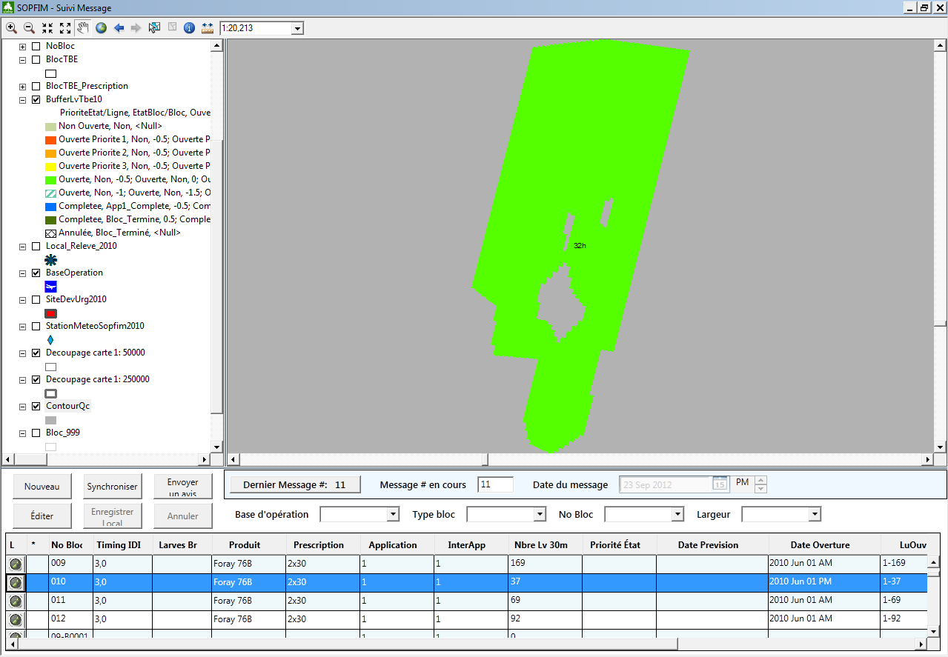

1. When I select a record the zoom in the bloc is not fool extended :

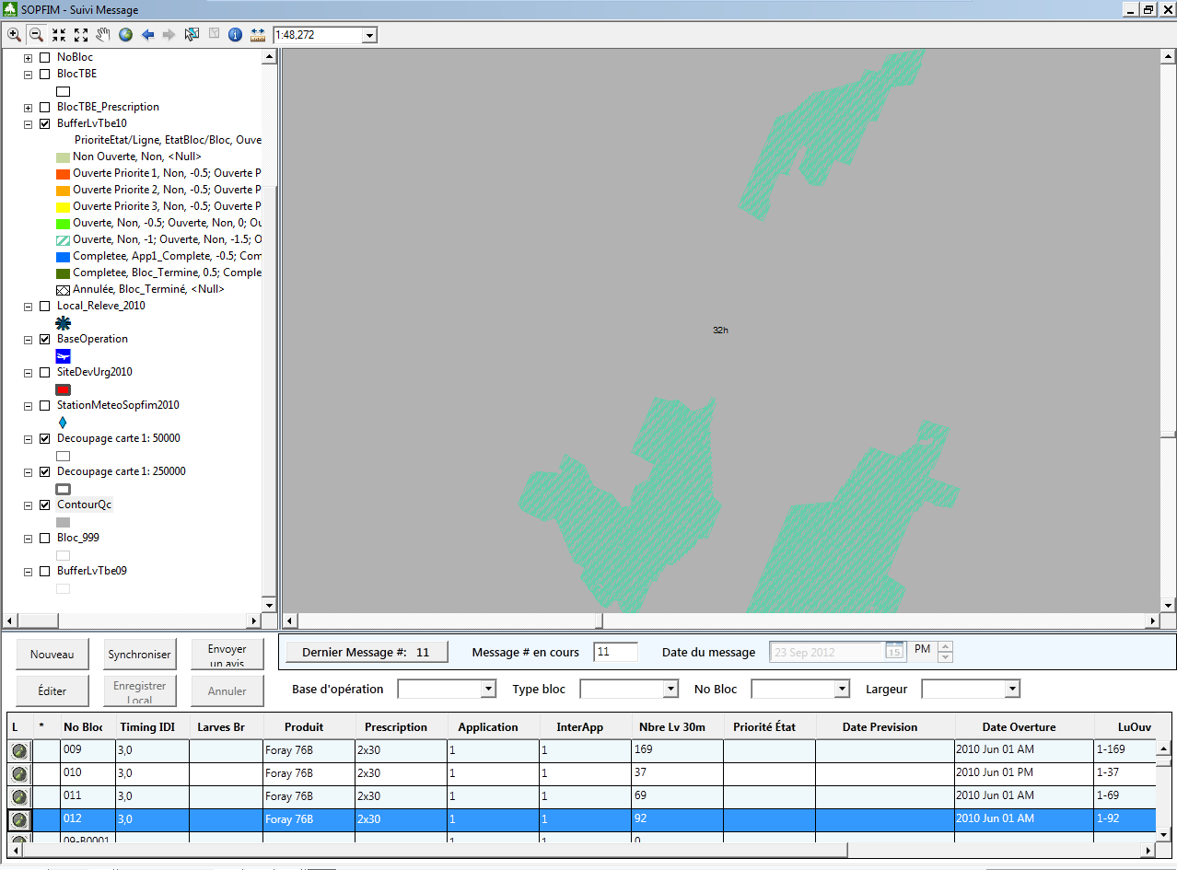

Must be like this :

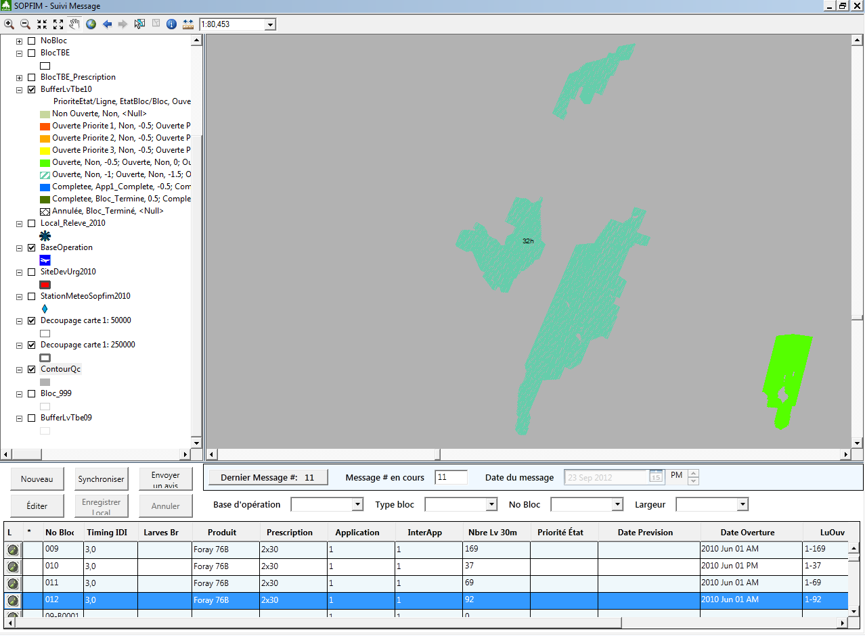

1. The filter by “Largeur” doesn’t work;
2. The text in the buttons “Envoyer un avis” and “Enregistrer local” are not readable. You can change the font of reduce the font size.

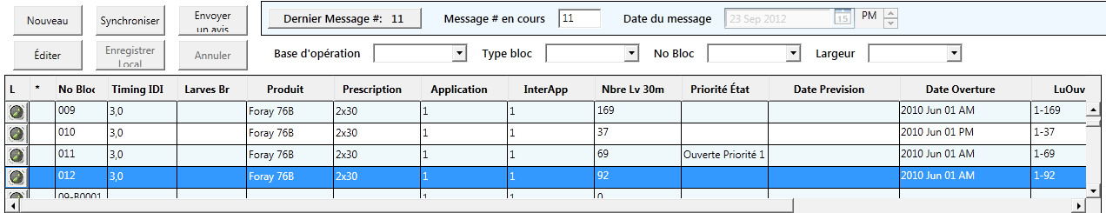

**Application Pulverisation :**

1. The text in the buttons “Envoyer un avis” and “Enregistrer local” are not readable. You can change the font of reduce the font size.